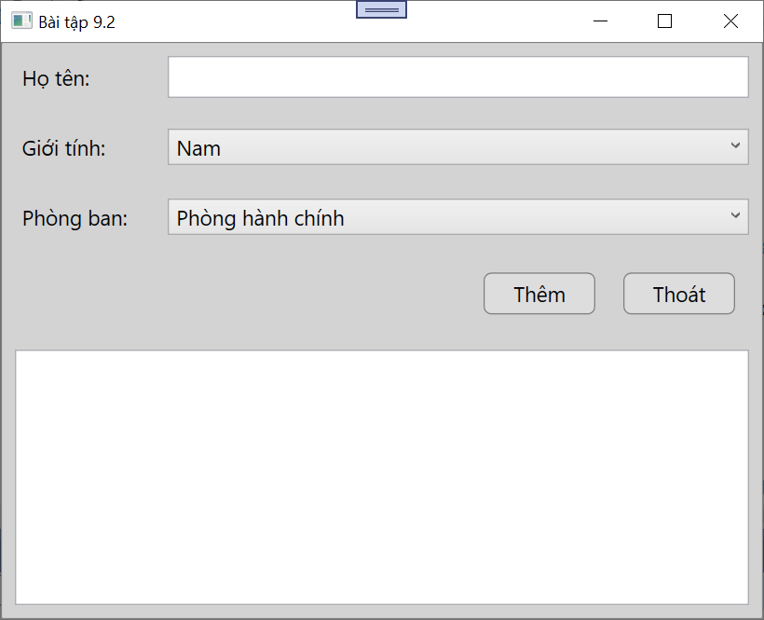

**CODE STYLE trong file App.xaml**

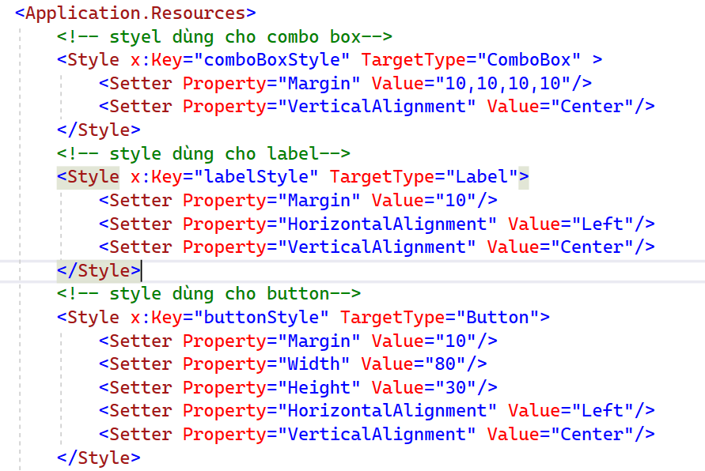

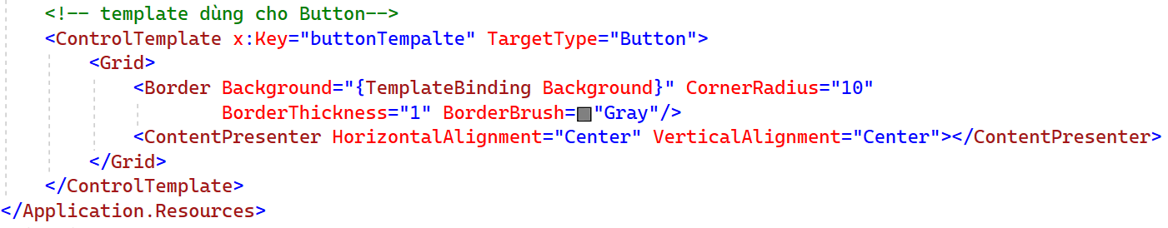

**CODE GIAO DIỆN**

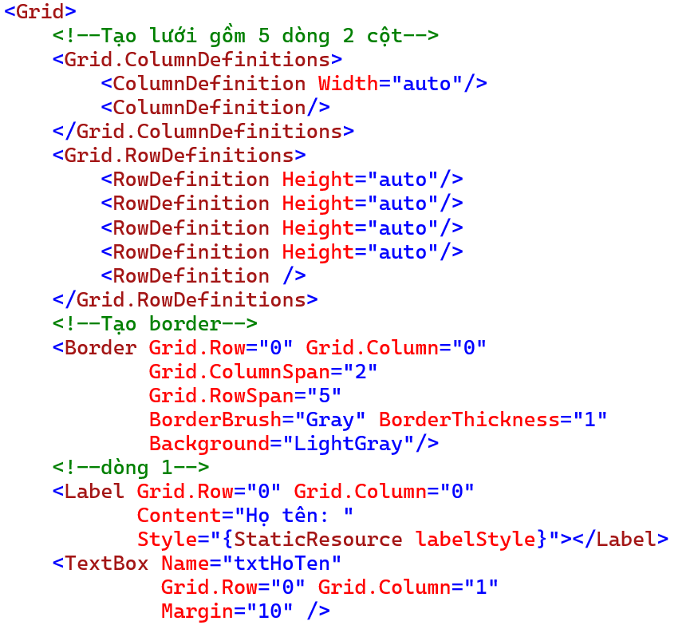

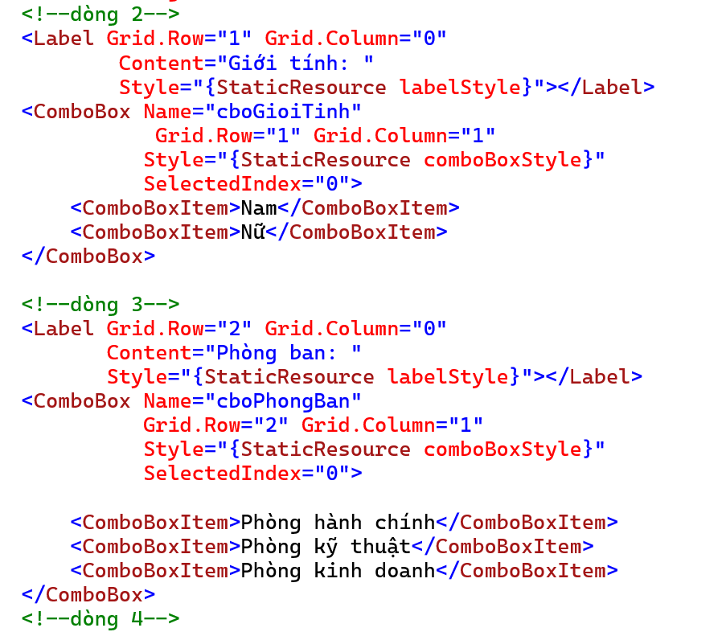

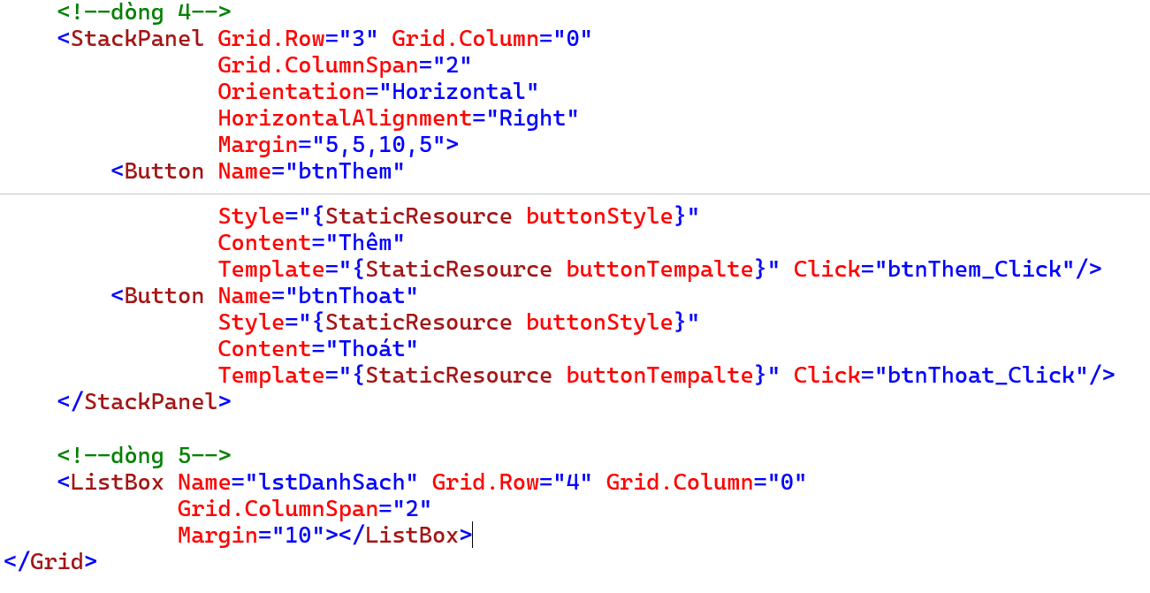

namespace BaiTap9_2

{

/// <summary>

/// Interaction logic for MainWindow.xaml

/// </summary>

public partial class MainWindow : Window

{

public MainWindow()

{

InitializeComponent();

}

private void btnThem_Click(object sender, RoutedEventArgs e)

{

string thongTin = txtHoTen.Text + " - " + cboGioiTinh.Text +

" - " + cboPhongBan.Text;

lstDanhSach.Items.Add(thongTin);

}

private void btnThoat_Click(object sender, RoutedEventArgs e)

{

var tl = MessageBox.Show("Bạn muốn kết thúc chương trình?",

"Exit", MessageBoxButton.YesNo, MessageBoxImage.Question);

if (tl == MessageBoxResult.Yes)

Environment.Exit(0);

}

}

}